**OBJECT ORIENTED PROGRAMMING THROUGH JAVA LAB**

**19CT1109**

**WEEK – 1**

a) Implement the following programs using command line arguments

i) Accept two strings from the user and print it on console with concatenation of “and” in the  middle of the strings.

**PROGRAM:**

class concat{

 public static void main(String[] args){

 if(args.length==2)

 {

 System.out.println(args[0]+" and "+args[1]);

 }

 else

 {

 System.out.println("Enter exactly 2 strings");

 }

 }

}

**OUTPUT:**

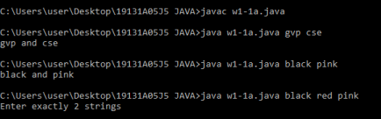

ii) Accept 12-hour time zone and convert into its corresponding 24-hour time zone. Note:  Accept hours, minutes and seconds separately from the user (e.g. 07 05 45 PM should be  displayed as 19:05:45).

**PROGRAM:**

class Timeline{

 public static void main(String[] args){

 int h1=(int)args[0].charAt(0)-'0';

 int h2=(int)args[0].charAt(1)-'0';

 int hh=((h1*10)+(h2%10));

 if(args[3].charAt(0)=='P')

 {

 if(hh==12)

 {

 System.out.println("The time in 24-hour format is 12:"+args[1]+":"+args[2]);  }

 else

 {

 hh=hh+12;

 System.out.println("The time in 24-hour format is "+ hh +":"+args[1]+":"+args[2]);

 }

 }

 else

 {

 if(hh==12)

 {

 System.out.println("The time in 24-hour format is 00:"+args[1]+":"+args[2]);  }

 else

 {

 System.out.println("The atime in 24-hour format is "+ hh +":"+args[1]+":"+args[2]);  }

 }

 }

}

**OUTPUT:**

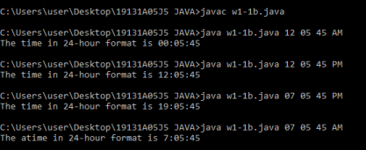

iii) Accept a number „n‟ and print the list of „n‟ Fibonacci terms recursively. **PROGRAM:**

class fibo

{

 static int a=0,b=0,c=1,num=0;

 public static void series(int n)

 {

 if(n>0)

 {

 a=b;

 b=c;

 c=a+b;

 System.out.print(a+" ");

 series(n-1);

 }

 }

 public static void main(String[] args)

 {

 num = Integer.parseInt(args[0]);

 series(num);

 }

}

**OUTPUT:**

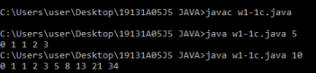

b) Perform the above programs using Scanner class.

i) Accept two strings from the user and print it on console with concatenation of “and” in the  middle of the strings.

**PROGRAM:**

import java.util.Scanner;

class concat

{

 public static void main(String[] args)

 {

 Scanner myobj=new Scanner(System.in);

 System.out.println("Enter the string 1: ");

 String str1=myobj.nextLine();

 System.out.println("Enter the string 2: ");

 String str2=myobj.nextLine();

 System.out.println(str1+" and "+str2);

 }

}

**OUTPUT:**

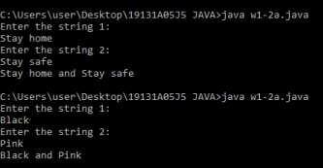

ii) Accept 12-hour time zone and convert into its corresponding 24-hour time zone. Note:  Accept hours, minutes and seconds separately from the user (e.g. 07 05 45 PM should be  displayed as 19:05:45).

**PROGRAM:**

import java.util.Scanner;

class Timeline{

 public static void main(String[] args){

 int i=0;

 Scanner obj=new Scanner(System.in);

 String str=obj.nextLine();

 int h1=(int)str.charAt(0)-'0';

 int h2=(int)str.charAt(1)-'0';

 int hh=((h1*10)+(h2%10));

 if(str.charAt(9)=='P')

 {

 if(hh==12)

 {

 System.out.print("The time in 24-hour format is ");

 System.out.print("12");

 for(i=2;i<8;i++)

 {

 if(str.charAt(i)==' ')

 {

 System.out.print(":");

 }

 else

 {

 System.out.print(str.charAt(i));

 }

 }

 }

 else

 {

 hh=hh+12;

 System.out.print("The time in 24-hour format is "+hh);  for(i=2;i<8;i++)

 {

 if(str.charAt(i)==' ')

 {

 System.out.print(":");

 }

 else

 {

 System.out.print(str.charAt(i));

 }

 }

 }

 }

 else

 {

 if(hh==12)

 {

 System.out.print("The time in 24-hour format is 00");  for(i=2;i<8;i++)

 {

 if(str.charAt(i)==' ')

 {

 System.out.print(":");

 }

 else

 {

 System.out.print(str.charAt(i));

 }

 }

 }

 else

 {

 System.out.print("The atime in 24-hour format is "+ hh);  for(i=2;i<8;i++)

 {

 if(str.charAt(i)==' ')

 {

 System.out.print(":");

 }

 else

 {

 System.out.print(str.charAt(i));

 }

 }

 }

 }

 }

}

**OUTPUT:**

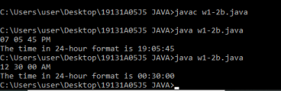

iii) Accept a number „n‟ and print the list of „n‟ Fibonacci terms recursively. **PROGRAM:**

import java.util.Scanner;

class fibo

{

 static int a=0,b=0,c=1,num=0;

 public static void series(int n)

 {

 if(n>0)

 {

 a=b;

 b=c;

 c=a+b;

 System.out.print(a+" ");

 series(n-1);

 }

 }

 public static void main(String[] args)

 {

 Scanner obj=new Scanner(System.in);

 System.out.print("Enter the number: ");

 num=obj.nextInt();

 series(num);

 }

}

**OUTPUT:**

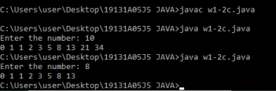

**WEEK - 2**

a) Write a program that accepts the set of inputs from the user of various integer data types and determines the primitive data type that is capable of properly storing that input

**PROGRAM:**

import java.util.*;

public class week21 {

public static void main(String[] args){

Scanner s = new Scanner(System.in);

System.out.print("Enter the No.of Elements : ");

int n = s.nextInt();

int[] a = new int[n];

System.out.print("Enter the Array Elements : ");

for(int i=0;i<n;i++){

a[i] = s.nextInt();

}

for(int i=0;i<n;i++){

System.out.println("The primitive Data Type of "+a[i]+" is : ");

if(a[i]>=Integer.MIN_VALUE && a[i]<=Integer.MAX_VALUE){

System.out.println("Int");

}

if(a[i]>=Short.MIN_VALUE && a[i]<=Short.MAX_VALUE){

System.out.println("Short");

}

if(a[i]>=Long.MIN_VALUE && a[i]<=Long.MAX_VALUE){

System.out.println("Long");

}

if(a[i]>=Byte.MIN_VALUE && a[i]<=Byte.MAX_VALUE){

System.out.println("Byte");

}

}

}

}

**OUTPUT:**

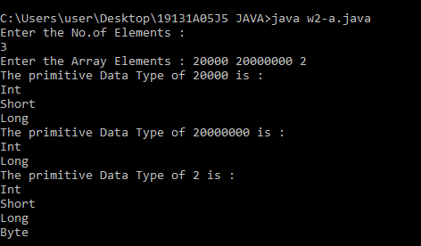

b) Write a program that accepts an array of integers and print those which are both odd and prime. If no such element in that array print “Not found”.

**PROGRAM:**

import java.util.Arrays;

import java.util.Scanner;

class w2a

{

public static void main(String[] args)

{

Scanner obj=new Scanner(System.in);

System.out.println("Enter the no.of elements: ");

int n=obj.nextInt();

int[] arr=new int[n];

int i,j;

System.out.println("Enter the array elements: ");

for(i=0;i<n;i++)

{

arr[i]=obj.nextInt();

}

System.out.println(Arrays.toString(arr));

System.out.print("The odd prime numbers in the given array are ");

for(i=0;i<n;i++)

{

int c=0;

if(arr[i]%2!=0&&arr[i]>1)

{

for(j=2;j<arr[i];j++)

{

if(arr[i]%j==0)

{

c++;

break;

}

}

if(c==0)

{

System.out.print(arr[i]+" ");

}

}

}

}

}

**OUTPUT:**

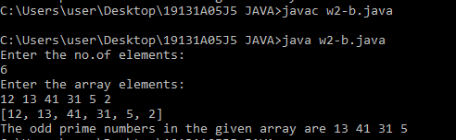

c) Write a program to accept contents into an Integer Array and print the frequency of each number in the order of their number of occurrences.

**PROGRAM:**

import java.util.Arrays;

import java.util.Scanner;

class w2c

{

public static void main(String[] args)

{

Scanner obj=new Scanner(System.in);

System.out.println("Enter the no.of elements: ");

int n=obj.nextInt();

int[] arr=new int[n];

int i;

System.out.println("Enter the array elements: ");

for(i=0;i<n;i++)

{

arr[i]=obj.nextInt();

}

Arrays.sort(arr);

int c=1;

i=0;

while(i<n-1)

{

if(arr[i]==arr[i+1])

{

c++;

}

else

{

System.out.println(arr[i]+" "+c);

c=1;

}

i++;

}

System.out.println(arr[n-1]+" "+c);

}

}

**OUTPUT:**

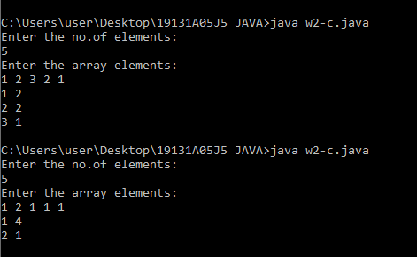

**WEEK - 3**

**3. a)** Write a program that accepts an „n‟ ordered square matrix elements into a single dimension array and print the elements of leading diagonal (top left to bottom right).

**PROGRAM:**

import java.util.Scanner; import java.util.Arrays; class w3a{ public static void main(String[] args)

{

System.out.println("Enter the 'n': "); Scanner obj=new Scanner(System.in); int n=obj.nextInt(); int[] arr=new int[n*n]; int i,j=0; for(i=0;i<n*n;i++)

{

arr[i]=obj.nextInt();

}

System.out.print("The elements of leading diagonal are "); for(i=0;i<n*n;i++)

{

if(i==0||i==n*j+j)

{

System.out.print(arr[i]+" "); j++;

}

}

}

}

**OUTPUT:**

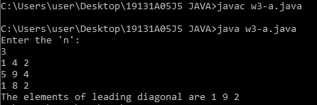

**3) b.** Write a program that accepts an „m x n‟ double dimension array, where „m‟ represents financial years and „n‟ represents Ids of the items sold. Each element in the array represents the number of items sold in a particular year. Identify the year and id of the item which has more demand.

**PROGRAM:**

import java.util.Scanner; import java.util.Arrays; class w3b{ public static void main(String[] args)

{

Scanner obj=new Scanner(System.in);

System.out.println("Enter the no.of years: "); int m=obj.nextInt();

System.out.println("Enter the no.of id's: "); int n=obj.nextInt(); int[][] arr=new int[m+1][n+1]; arr[0][0]=0; int i,j,y=0,id=0,max=0;

System.out.println("Enter the years: "); for(i=1;i<=m;i++)

{

arr[i][0]=obj.nextInt();

}

System.out.println("Enter the id's: "); for(i=1;i<=n;i++)

{

arr[0][i]=obj.nextInt();

}

System.out.println("Enter the no.of items sold in a particular year: "); for(i=1;i<=m;i++)

{

for(j=1;j<=n;j++)

{

arr[i][j]=obj.nextInt(); if(arr[i][j]>max)

{

max=arr[i][j];

y=i; id=j;

}

}

}

System.out.println("The year and id of the item which has more demand

are: "+arr[y][0]+" "+arr[0][id]);

}

}

**OUTPUT:**

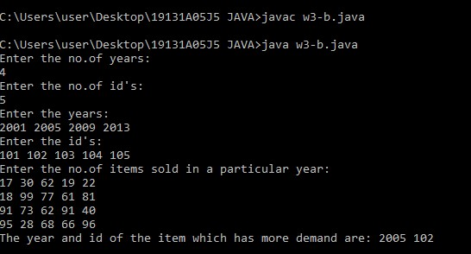

**3) c**. Write a program that accepts an „n‟ ordered square matrix and calculate the absolute difference between the sums of elements in their diagonals.

**PROGRAM:**

import java.util.Scanner; import java.util.Arrays; class w3c{

public static void main(String[] args)

{

System.out.println("Enter the 'n': "); Scanner obj=new Scanner(System.in); int n=obj.nextInt(); int[][] arr=new int[n][n]; int i,j,ld=0,rd=0; for(i=0;i<n;i++)

{

for(j=0;j<n;j++)

{

arr[i][j]=obj.nextInt(); if(i==j) ld=ld+arr[i][j];

if(i+j==n-1) rd=rd+arr[i][j];

}

}

System.out.println(Math.abs(ld-rd));

}

}

**OUTPUT:**

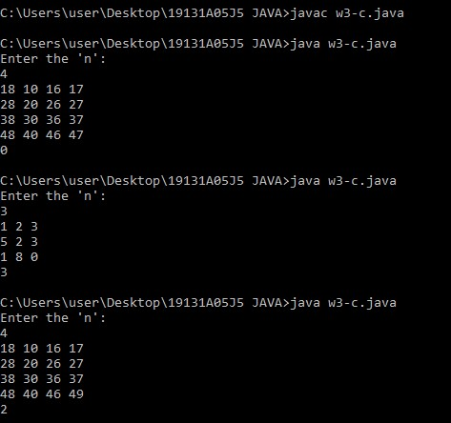

**WEEK - 4**

**4) a.** Create a class Box that uses a parameterized constructor to initialize the dimensions of a box. The dimensions of the Box are width, height, depth. The class should have a method that can return the volume of the box. Create an object of the Box class and test the functionality.

**PROGRAM:**

import java.util.Scanner; class w4a{ public static void main(String[] args)

{

Scanner obj=new Scanner(System.in);

System.out.print("Enter the depth of the box: "); double d=obj.nextDouble(); System.out.print("Enter the width of the box: "); double w=obj.nextDouble();

System.out.print("Enter the height of the box: "); double h=obj.nextDouble();

Box box=new Box(d,w,h);

System.out.println("The volume of the box is "+box.volume());

}

}

class Box{ private double depth; private double width; private double height;

public Box(double a,double b,double c)

{

this.depth=a; this.width=b; this.height=c;

}

public double volume()

{

return depth*width*height;

}

}

**OUTPUT:**

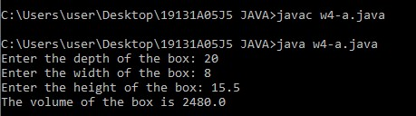

**4.b)** Create a new class called Calculator with the following methods:

* A static method called powerInt(int num1,int num2) This method should return num1 to the power num2.
* A static method called powerDouble(double num1,double num2).

This method should return num1 to the power num2.

* Invoke both the methods and test the functionality. Also count the number of objects created.

**PROGRAM:**

import java.util.Scanner; public class w4b {

public static void main(String[] args) {

Scanner obj=new Scanner(System.in);

System.out.print("Enter the integer numbers: "); int i1=obj.nextInt(); int i2=obj.nextInt();

System.out.print("Enter the double numbers: "); double d1=obj.nextDouble();

Double d2=obj.nextDouble();

System.out.println("Integer num1 raised to the power of num2 gives:

"+Calculator.powerInt(i1, i2));

System.out.println("Double num1 raised to the power of num2 gives:

"+Calculator.powerDouble(d1, d2));

System.out.println("The number of objects created are:

"+Calculator.Count()+" since the methods are static.");

}

}

class Calculator {

static int count=0; Calculator(){ count++;

}

public static int Count(){

return count;

}

public static int powerInt(int num1, int num2) { return (int) Math.pow(num1, num2);

}

public static double powerDouble(double num1, double num2) { return Math.pow(num1, num2);

}

}

**OUTPUT:**

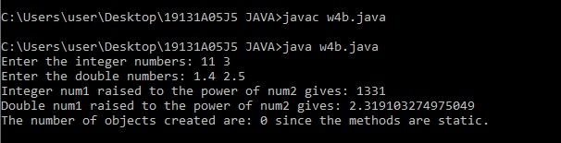

**WEEK – 5**

**5)a)** Accept a String and a number „n‟ from user. Divide the given string into substrings each of size „n‟ and sort them lexicographically

**PROGRAM:**

import java.util.*;

class w5a{

public static void main(String[] args){

Scanner obj=new Scanner(System.in);

System.out.print("Enter the string: ");

String str=obj.nextLine();

System.out.print("Enter the number: ");

int n=obj.nextInt();

int len=str.length();

int part_size=len/n;

if(len%n!=0)

part_size++;

String[] strarr=new String[part_size];

int j=0;

for(int i=0;i<len;i++)

{

if(i>(len-(len%n)-1))

{

strarr[j]=str.substring(len-(len%n),len);

break;

}

else

{

strarr[j]=str.substring(i,i+n);

j++;

i=i+n-1;

}

}

System.out.print("The substrings are: ");

for(String st:strarr)

System.out.print(st+" ");

for(int i=0;i<strarr.length;i++)

{

for(j=i+1;j<strarr.length;j++)

{

if(strarr[i].compareToIgnoreCase(strarr[j])>0)

{

String temp=strarr[i];

strarr[i]=strarr[j];

strarr[j]=temp;

}

}

}

System.out.print("\nThe substrings after sorting lexicographically: ");

for(String st:strarr)

System.out.print(st+" ");

}

}

**OUTPUT:**

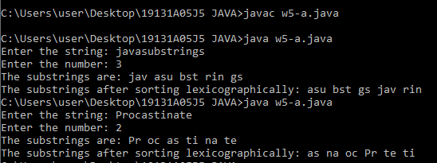

**5)b)** Accept an array of strings and display the number of vowels and consonants occurred in each string.

**PROGRAM:**

import java.util.*;

class w5b{

public static void main(String[] args)

{

Scanner obj=new Scanner(System.in);

String str=obj.nextLine();

int vowel=0,cons=0;

int len=str.length();

for(int i=0;i<len;i++)

{

if(str.charAt(i)=='a'||str.charAt(i)=='e'||str.charAt(i)=='i'||str.charAt(i)=='o'||str.charAt(i)=='u'||str.charAt(i)=='A'||str.charAt(i)=='E'||str.charAt(i)=='I'||str.charAt(i)=='O'||str.charAt(i)=='U')

vowel++;

else if(str.charAt(i)>65&&str.charAt(i)<91||str.charAt(i)>97&&str.charAt(i)<123)

cons++;

}

System.out.println("The no.of vowels in the string are "+vowel);

System.out.println("The no.of consonants in the string are "+cons);

}

}

**OUTPUT:**

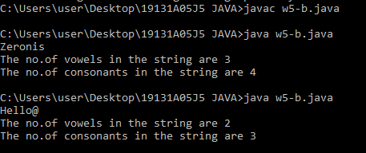

**5)c)** Accept two strings from the user and determine if the strings are anagrams or not.

**PROGRAM:**

import java.util.*;

class w5c{

public static void main(String[] args)

{

Scanner obj=new Scanner(System.in);

System.out.print("Enter the 2 strings: ");

String s1=obj.nextLine();

String s2=obj.nextLine();

String str1=s1.replaceAll("\\s", "");

String str2=s2.replaceAll("\\s", "");

boolean flag;

if(str1.length()!=str2.length())

flag=false;

else

{

char[] arr1=str1.toLowerCase().toCharArray();

char[] arr2=str2.toLowerCase().toCharArray();

Arrays.sort(arr1);

Arrays.sort(arr2);

flag=Arrays.equals(arr1,arr2);

}

if(flag)

System.out.println(s1+" and "+s2+" are anagrams");

else

System.out.println(s1+" and "+s2+" are not anagrams");

}

}

**OUTPUT:**

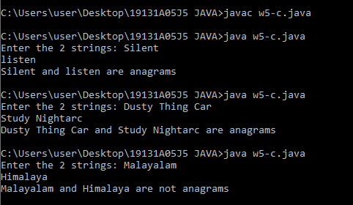

**WEEK – 6**

**6)a)** Create a multilevel inheritance for classes vehicle, brand and cost. The vehicle class determines the type of vehicle which is inherited by the class brand which determines the brand of the vehicle. Brand class is inherited by cost class, which tells about the cost of the vehicle. Create another class which calls the constructor of cost class and method that displays the total vehicle information from the attributes available in the super classes.

**PROGRAM:**

import java.util.*;

class w6a{

public static void main(String[] args){

Scanner obj=new Scanner(System.in);

System.out.print("Enter the type of the vehicle: ");

String type=obj.nextLine();

System.out.print("Enter the brand of the vehicle: ");

String brand=obj.nextLine();

System.out.print("Enter the cost of the vehicle: ");

int cost=obj.nextInt();

System.out.println("Information of the vehicle.....");

cost info=new cost(type,brand,cost);

}

}

class vehicle

{

String type;

public void typeOfVehicle(String type)

{

this.type=type;

System.out.println("The vehicle is of type "+type);

}

}

class brand extends vehicle

{

String brand;

public void brandOfVehicle(String brand)

{

this.brand=brand;

System.out.println("The vehivcle is of brand "+brand);

}

}

class cost extends brand

{

int cost;

public void costOfVehicle(int cost)

{

this.cost=cost;

System.out.println("The cost of the vehivcle is "+cost);

}

cost(String type,String brand,int cost)

{

typeOfVehicle(type);

brandOfVehicle(brand);

costOfVehicle(cost);

}

}

**OUTPUT:**

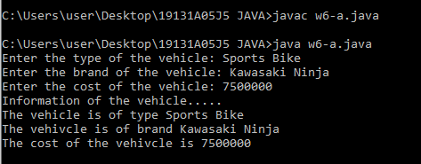

**6)b)** Create an inheritance hierarchy of Figure_3D, Cylinder, Cone, Sphere etc. In the base class and provide methods that are common to all Figure_3Ds and override these in the derived classes to perform different behaviors, depending on the specific type of Figure_3D. Create an array of Figure_3D, fill it with different specific types of Figure_3Ds and call your base class methods.

**PROGRAM:**

import java.util.*;

import java.lang.Math;

class w6b{

public static void main(String[] args)

{

Scanner obj=new Scanner(System.in);

Figure_3D[] figure_3ds=new Figure_3D[3];

figure_3ds[0]=new Cylinder();

figure_3ds[1]=new Cone();

figure_3ds[2]=new Sphere();

boolean flag=true;

while(flag)

{

System.out.print("0.Cylinder\n1.Cone\n2.Sphere\n3.Exit\nEnter the number of the figure you want to find area of: ");

int a=obj.nextInt();

if(a!=0&&a!=1&&a!=2)

{

System.out.println("Enter valid number!");

break;

}

else if(a==2)

{

System.out.print("Enter the radius of the circle: ");

double r=obj.nextDouble();

figure_3ds[2].area(r,0);

}

else

{

System.out.print("Enter the radius: ");

double r=obj.nextDouble();

System.out.print("Enter the height: ");

double h=obj.nextDouble();

figure_3ds[a].area(r,h);

}

}

}

}

class Figure_3D

{

void area(double r,double h)

{}

}

class Cylinder extends Figure_3D

{

void area(double r,double h)

{

double area=2*3.14*r*(r+h);

System.out.println("The area of the cylinder is "+area);

}

}

class Cone extends Figure_3D

{

void area(double r,double h)

{

double e=Math.pow((h*h+r*r),0.5);

double area=3.14*r*(r+e);

System.out.println("The area of the cone is "+area);

}

}

class Sphere extends Figure_3D

{

void area(double r,double h)

{

double area=4*3.14*r*r;

System.out.println("The area of the cylinder is "+area);

}

}

**OUTPUT:**

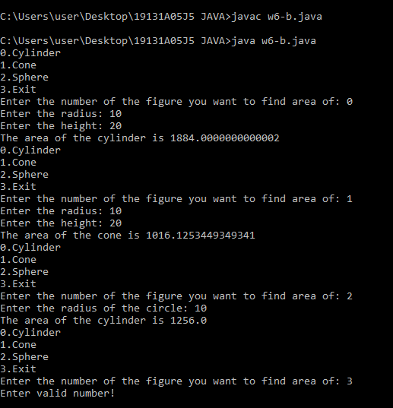

**WEEK – 7**

**7 a.** Design a package to contain the class Student that contains data members such as name, roll number and another package contains the interface Sports which contains some sports information. Import these two packages in a package called Report which process both Student and Sport and give the report

**PROGRAM:**

package report;

import students.*;

import sport.*;

import java.util.*;

class info{

public static void main(String[] args)

{

Scanner o=new Scanner(System.in);

System.out.print("Enter the name: ");

String name=o.nextLine();

System.out.print("Enter the sport: ");

String sport=o.nextLine();

System.out.print("Enter the rollno: ");

int rollno=o.nextInt();

System.out.println("REPORT....");

student obj=new student();

obj.sportsinfo(name,rollno);

a obj2=new a();

obj2.sportsinfo(sport);

}

}

class a implements sports{

public void sportsinfo(String sport)

{

System.out.println("Sport the person plays: "+sport);

}

}

/*

*Contents in student package(student.java):*

*package students;*

*public class student{*

*public void sportsinfo(String name, int rollno)*

*{*

*System.out.println("Name: "+name+"\n"+"Roll.no: "+rollno);*

*}*

*}*

*Contents in sports package(sports.java):*

*package sport;*

*public interface sports{*

*void sportsinfo(String sport);*

*}*

*\*/*

**OUTPUT:**

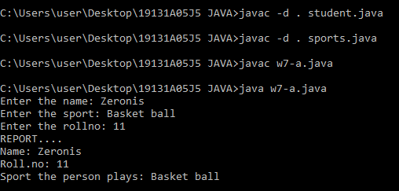

**7.b.** Write a program that accepts values of different data types and convert them to corresponding wrapper classes and display using the vector

**PROGRAM:**

import java.util.*;

class wrapper

{

    public static void main(String[] args)

{

        Vector v = new Vector();

        int i=100;

        float ft= 6.3f;

        char ch='S';

        boolean bl = true;

        Integer a =i;

        Float  b =ft;

        Character c = ch;

        Boolean d = bl;

        v.add(a);

        v.add(b);

        v.add(c);

        v.add(d);

        System.out.println(v);

    }

}

**OUTPUT:**

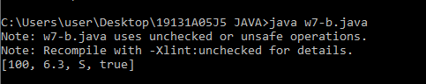

**WEEK – 8**

**8.a.** Write a program to generate a set of random numbers between two numbers x1 and x2, and x1>0.

**PROGRAM:**

import java.util.*;

 class randnum

 {

public static void main(String[] args)

{

Scanner s=new Scanner(System.in);

System.out.println("Enter the two nmbers: ");

int x1=s.nextInt();

int x2=s.nextInt();

int max=x1>x2?x1:x2;

int min=x1>x2?x2:x1;

Random rand=new Random();

for(int i=0;i<5;i++)

{

System.out.print(rand.nextInt(max-min+1)+min+" ");

}

}

 }

**OUTPUT:**

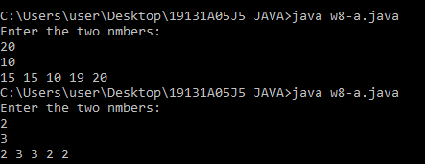

**8.b.** Write a program to implement a new ArrayList class. It should contain add(), get(), remove(), size() methods. Use dynamic array logic.

**PROGRAM:**

import java.util.*;

class ArrayList

{

private static int[] arr=new int[1];

private static int count=0;

private static int size=1;

public static void main(String[] args)

{

Scanner s=new Scanner(System.in);

size();

System.out.print("Enter the no.of elements:");

int n=s.nextInt();

System.out.println("Enter the elements:");

for(int i=0;i<n;i++)

{

int a=s.nextInt();

add(a);

}

System.out.print("The array  ");

for(int i=0;i<n;i++)

{

System.out.print(arr[i]+"  ");

}

System.out.print("\n");

size();

System.out.print("Enter the index you wish for ");

int in=s.nextInt();

get(in);

System.out.println("Removing an element...");

remove();

System.out.print("The array  after removing ");

for(int i=0;i<n;i++)

{

System.out.print(arr[i]+"  ");

}

}

public static void add(int x)

{

if(count==size)

{

int[] temp=new int[size*2];

for(int i=0;i<size;i++)

{

temp[i]=arr[i];

}

arr=temp;

size=size*2;

}

arr[count]=x;

count++;

}

public static void remove()

{

if(count>0)

{

arr[count-1]=0;

count--;

}

}

public static void size()

{

System.out.println("Size of the array: "+size);

}

public static void get(int i)

{

System.out.println("Element at index "+i+" is "+arr[i]);

}

}

**OUTPUT:**

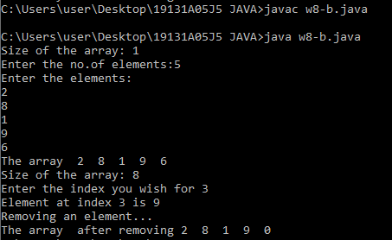

**8.c.** Create an employee class containing at least 3 details along with Id, setters and getters. Insert the employee objects dynamically key as employee id and value as it’s corresponding object into a HashMap. Perform Id based search operation on the HashMap.

**PROGRAM:**

import java.util.*;

class w8c{

public static void main(String[] args)

{

Scanner obj=new Scanner(System.in);

HashMap<Integer,employee> hm=new HashMap<Integer,employee>();

employee o1=new employee();

o1.setter(1,"Zeronis","Developer");

hm.put(o1.getid(),o1);

employee o2=new employee();

o2.setter(2,"Richt","HR");

hm.put(o2.getid(),o2);

employee o3=new employee();

o3.setter(3,"Yohan","Developer");

hm.put(o3.getid(),o3);

System.out.print("Enter the id to serach: ");

int s=obj.nextInt();

if(hm.containsKey(s))

{

employee emp=hm.get(s);

System.out.println("ID: "+emp.getid());

System.out.println("Name: "+emp.getname());

System.out.println("Role: "+emp.getrole());

}

}

}

class employee{

int id;

String role,name;

void setter(int id,String name,String role)

{

this.id=id;

this.name=name;

this.role=role;

}

int getid()

{

return id;

}

String getname()

{

return name;

}

String getrole()

{

return role;

}

}

**OUTPUT:**

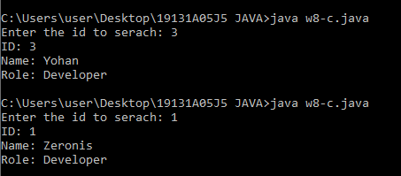

**WEEK – 9**

**9. a.** Write a program that reads file name from the user then displays information about that file, also read the contents from the file in byte stream to count number of alphabets, numeric values and special symbols. Write these statistics into another file using byte streams.

**PROGRAM:**

import java.io.File;

import java.io.InputStream;

import java.io.OutputStream;

import java.io.FileInputStream;

import java.util.Date;

import java.io.*;

import java.util.*;

class w9a {

public static void main(String[] args) {

try {

Scanner obj = new Scanner(System.in);

System.out.print("Enter the name of the file along with extension : ");

String filename = obj.nextLine();

File file = new File(filename);

long size = file.length();

System.out.println("Information about the file....");

System.out.println("File name : " + file.getName());

System.out.println("Absolute path : " + file.getAbsolutePath());

System.out.println("Size : " + file.length());

System.out.println("Last Modified : " + new Date(file.lastModified()));

System.out.println();

InputStream input = new FileInputStream(filename);

int alphabets = 0, numbers = 0, spclchar = 0,n;

while((n=input.read())!=-1)

{

if(((char)n>64 && (char)n<91) || ((char)n>96 && (char)n<123))

alphabets++;

else if((char)n>=48 && (char)n<=57)

numbers++;

else if((char)n!=32)

spclchar++;

}

System.out.println("Number of alphabets : " + alphabets);

System.out.println("Number of numeric values : " + numbers);

System.out.println("Number of special characters : " + spclchar);

System.out.print("Enter the name of the file where the statistics are to be copied : ");

String outputfile = obj.nextLine();

OutputStream output = new FileOutputStream(outputfile);

output.write(("Characters count of the text in " + file.getName()).getBytes());

output.write(("\nNumber of alphabets : " + alphabets).getBytes());

output.write(("\nNumber of numeric values : " + numbers).getBytes());

output.write(("\nNumber of special characters : " + spclchar).getBytes());

output.close();

input.close();

System.out.println("The statistics of " + filename +" has been copied to " + outputfile);

}

catch(Exception e) {

e.getStackTrace();

}

}

}

**INPUT FILE:**

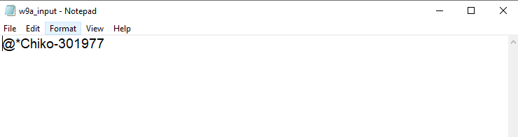

**OUTPUT:**

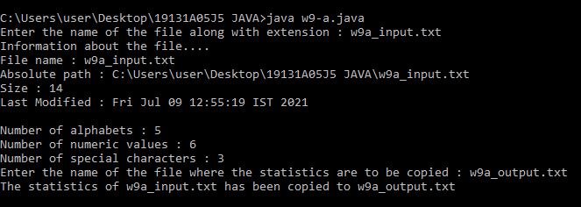

**OUTPUT FILE:**

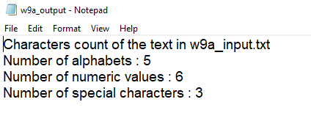

**9.b.** Write a program that reads a CSV file containing a super market data containing product ID, Name, Cost and Quantity of sales and calculate the total revenue of the super market also sort the products in the order of their demand.

**PROGRAM:**

import java.io.*;

import java.util.*;

import java.util.ArrayList;

class w9b{

public static void main(String[] args){

try{

Scanner o = new Scanner(System.in);

System.out.print("Enter the file name : ");

String file = o.nextLine();

BufferedReader br = new BufferedReader(new FileReader(file));

String line;

int total_revenue = 0;

List<String[]> list = new ArrayList<>();

ArrayList<Integer> n = new ArrayList<Integer>();

while((line = br.readLine())!=null)

{

String[] s = line.split(",");

n.add(Integer.parseInt(s[3]));

list.add(s);

total_revenue +=Integer.parseInt(s[3]) * Integer.parseInt(s[2]);

}

Collections.sort(n);

System.out.println("Sorting the products in the increasing order of their demand....");

for(int i=0;i<n.size();i++)

{

for(String[] arr : list)

{

if(Integer.parseInt(arr[3])==n.get(i))

{

sort_products obj = new sort_products(arr);

System.out.println(obj.toString());

break;

}

}

}

System.out.println("The total revenue of the super market : " + total_revenue);

br.close();

}

catch(Exception e)

{

System.out.println("File doesn't exixt!!");

}

}

}

class sort_products {

String[] items;

sort_products(String[] items)

{

this.items = items;

}

public String toString(){

return items[0] + "," + items[1] + "," + items[2] + "," + items[3];

}

}

**INPUT FILE :**

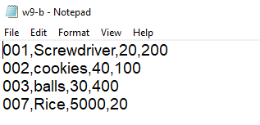

**OUTPUT:**

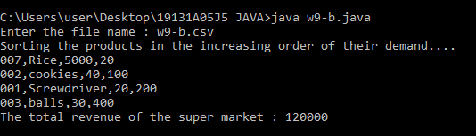

**9.C.** Write a program that reads a text file containing some technical content and identify the technical terms and sort them alphabetically. Note: use a file containing stop words (general English and Grammar terms as many terms as possible)

**PROGRAM:**

import java.io.*;

import java.util.*;

class w9c {

public static void main(String[] args)

{

try {

Scanner o = new Scanner(System.in);

System.out.print("Enter the file name : ");

String file = o.nextLine();

BufferedReader br = new BufferedReader(new FileReader(file));

String str = null;

String[] words = null;

while((str = br.readLine())!= null)

{

words = str.split(" ");

}

Arrays.sort(words);

for(int i=0;i<words.length;i++)

{

System.out.print(words[i] + "  ");

}

}

catch(Exception e)

{

e.getStackTrace();

}

}

}

**INPUT FILE:**

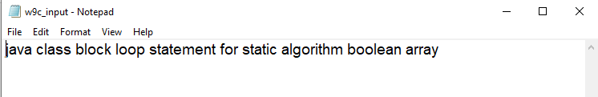

**OUTPUT:**

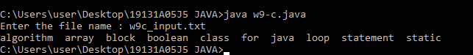

**WEEK – 10**

**10. a.** Write a program that reads two numbers from the user to perform integer division into Num1 and Num2 variables. The division of Num1 and Num2 is displayed if they are integers. If Num1 or Num2 were not an integer, the program would throw a Number Format Exception. If Num2 were Zero, the program would throw an Arithmetic Exception.

**PROGRAM:**

import java.util.*;

import java.io.*;

class w10{

public static void main(String[] args)

{

try{

Scanner obj = new Scanner(System.in);

System.out.print("Enter the 2 numbers : ");

int num1 = Integer.parseInt(obj.next());

int num2 = Integer.parseInt(obj.next());

if(num2==0)

throw new ArithmeticException("Division by zero is not valid!!!");

else

System.out.println(num1/num2);

}

catch (NumberFormatException e) {

throw new NumberFormatException("One of them is not a valid string to be convered to integer");

}

}

}

**OUTPUT:**

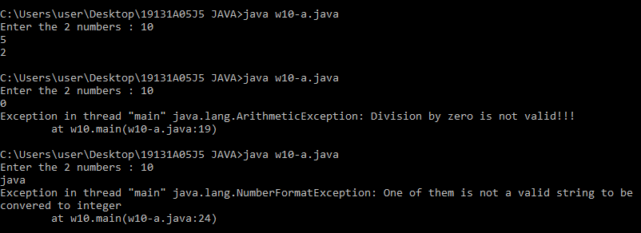

**10. b.** Create a user defined exception.

**PROGRAM:**

import java.util.*;

import java.io.*;

class w10b{

public static void main(String[] args)

{

Scanner s = new Scanner(System.in);

System.out.print("Enter your marks : " );

int marks = s.nextInt();

try{isEligible(marks);}

catch(Exception ex){

System.out.println("Exception occured : " + ex);

}

}

static void isEligible(int marks) throws notEligible

{

if(marks>60)

System.out.println("Opening the test window...");

else

throw new notEligible("Better luck next time...");

}

}

class notEligible extends Exception{

notEligible(String s){

super(s);

}

}

**OUTPUT:**

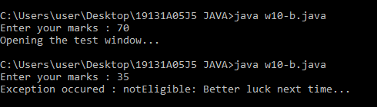

**WEEK – 11**

**11.a.** Write a program that creates 3 threads by extending the Thread class. First thread displays “Good Morning” every 1 sec, the second thread displays “Hello” every 2 seconds and the third displays Welcome” every 3 seconds.

**PROGRAM:**

import java.util.*;

import java.io.*;

class w11a{

public static void main(String[] args) {

sec1 Thread1 = new sec1();

sec2 Thread2 = new sec2();

sec3 Thread3 = new sec3();

Thread1.start();

Thread2.start();

Thread3.start();

}

}

class sec1 extends Thread{

synchronized public void run(){

try

{

int i=0;

while(i<5){

sleep(1000);

System.out.println("Good Morning");

i++;

}

}

catch(Exception e){}

}

}

class sec2 extends Thread{

synchronized public void run(){

try{

int i=0;

while(i<5){

sleep(2000);

System.out.println("Hello");

i++;

}

}

catch(Exception e){}

}

}

class sec3 extends Thread{

synchronized public void run(){

try{

int i=0;

while(i<5){

sleep(3000);

System.out.println("Welcome");

i++;

}

}

catch(Exception e){}

}

}

**OUTPUT:**

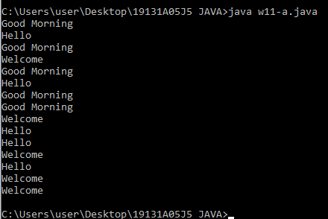

**11.a.sub.** Implementing the above program using runnable

**PROGRAM:**

import java.util.*;

import java.io.*;

class w11a{

public static void main(String[] args) {

sec1 o1 = new sec1();

sec2 o2 = new sec2();

sec3 o3 = new sec3();

Thread Thread1 = new Thread(o1);

Thread Thread2 = new Thread(o2);

Thread Thread3 = new Thread(o3);

Thread1.start();

Thread2.start();

Thread3.start();

}

}

class sec1 implements Runnable{

synchronized public void run(){

try

{

int i=0;

while(i<5){

Thread.sleep(1000);

System.out.println("Good Morning");

i++;

}

}

catch(Exception e){}

}

}

class sec2 implements Runnable{

synchronized public void run(){

try{

int i=0;

while(i<5){

Thread.sleep(2000);

System.out.println("Hello");

i++;

}

}

catch(Exception e){}

}

}

class sec3 implements Runnable{

synchronized public void run(){

try{

int i=0;

while(i<5){

Thread.sleep(3000);

System.out.println("Welcome");

i++;

}

}

catch(Exception e){}

}

}

**OUTPUT:**

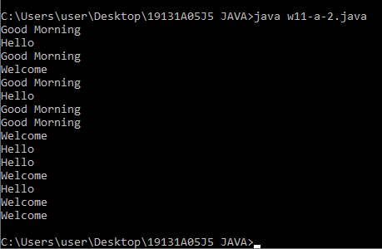

**11. b.** Write a program to illustrate Thread synchronization.

**PROGRAM:**

class w11b extends Thread{

public static void main(String[] args)

{

w11b obj = new w11b();

Thread t1 = new Thread(obj);

Thread t2 = new Thread(obj);

t1.setName("t1");

t2.setName("t2");

t1.start();

t2.start();

}

synchronized public void table(int num)

{

for(int i=1;i<=5;i++)

{

System.out.println(i*num);

try{

Thread.sleep(500);

}

catch(Exception e)

{}

}

}

public void run()

{

String name = Thread.currentThread().getName ();

if(name.equals("t1"))

table(10);

else

table(20);

}

}

**OUTPUT:**

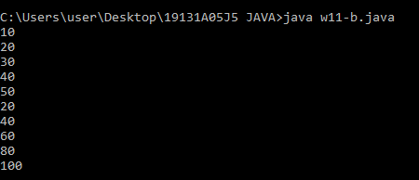

**WEEK – 12**

**12.a)** Create a JApplet that displays a message which is scrolling from left to right and vice versa

**PROGRAM:**

import java.awt.Graphics;

import javax.swing.*;

/*

<applet code = "Hello.class" width = "250" height = "200"></applet>

*/

class welcome extends JApplet implements Runnable{

int x;

@Override

public void init(){

Thread r1 = new Thread(this);

r1.start();

}

@Override

public void run(){

while(true){

x = 50;

try{

for(; x <= 150; x += 10){

repaint();

Thread.sleep(1000);

}

for(; x >= 100; x -= 10){

repaint();

Thread.sleep(1000);

}

}catch(Exception e){

System.out.println(e);

}

}

}

public void paint(Graphics g){

super.paint(g);

g.drawString("Welcome", x, 100);

}

}

**OUTPUT:**

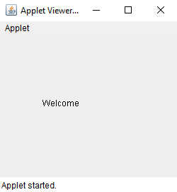 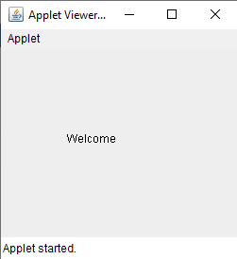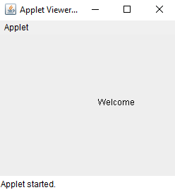 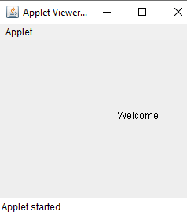

**12.b)** Write a program that displays a sample registration page using Swing controls use appropriate layout managers.

**PROGRAM:**

import javax.swing.*;

import java.awt.*;

class w12_b {

public static void main(String[] args){

new w12_b();

}

w12_b(){

JFrame frame = new JFrame();

JTextField firstName, lastName, email;

JRadioButton cse, civil, ece;

JTextArea textArea = new JTextArea("Leave a query?", 10, 20);

JCheckBox checkBox = new JCheckBox("Subscribe for mails");

ButtonGroup bGroup = new ButtonGroup();

JPanel panel = new JPanel(new GridLayout(4, 1, 10, 10));

JLabel lbl = new JLabel("Select the Branch:");

JButton submitBtn = new JButton("Submit");

submitBtn.setSize(70, 40);

firstName = new JTextField("Enter the First Name", 15);

lastName = new JTextField("Enter the Last Name", 15);

email = new JTextField("Enter the Email", 15);

cse = new JRadioButton("CSE");

ece = new JRadioButton("ECE");

civil = new JRadioButton("Civil");

//Adding radio buttons to Buttons Group

bGroup.add(cse);

bGroup.add(ece);

bGroup.add(civil);

//Adding branch selection components to panel

panel.add(lbl);

panel.add(cse);

panel.add(ece);

panel.add(civil);

frame.add(firstName);

frame.add(lastName);

frame.add(email);

frame.add(panel);

frame.add(textArea);

frame.add(checkBox);

frame.add(submitBtn);

frame.setLayout(new FlowLayout(1, 10, 10));

frame.setVisible(true);

frame.setSize(300, 500);

frame.setDefaultCloseOperation(3);

}

}

**OUTPUT:**

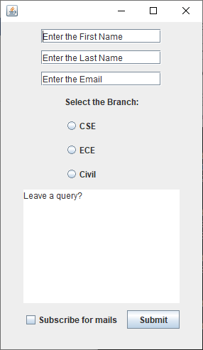

**12.c)** Write a program for handling mouse events with adapter classes.

**PROGRAM:**

import javax.swing.*;

import java.awt.event.*;

public class w12_c implements MouseListener{

JLabel lbl = new JLabel("This Label");

JFrame frame;

w12_c(){

frame = new JFrame();

lbl.setBounds(50, 100, 100, 30);

frame.addMouseListener(this);

frame.add(lbl);

frame.setSize(300, 300);

frame.setLayout(null);

frame.setVisible(true);

frame.setDefaultCloseOperation(3);

}

@Override

public void mouseClicked(MouseEvent e) {

lbl.setText("Mouse Clicked");

}

@Override

public void mousePressed(MouseEvent e) {

lbl.setText("Mouse Pressed!");

}

@Override

public void mouseReleased(MouseEvent e) {

lbl.setText("Mouse Released");

}

@Override

public void mouseEntered(MouseEvent e) {

lbl.setText("Mouse Entered");

}

@Override

public void mouseExited(MouseEvent e) {

lbl.setText("Mouse Exited");

}

public static void main(String[] args) {

new w12_c();

}

}

**OUTPUT:**

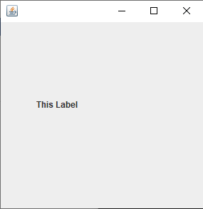 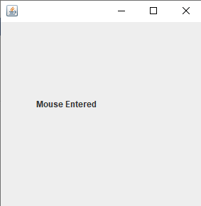

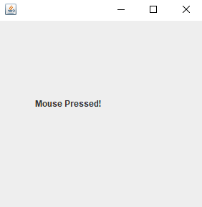 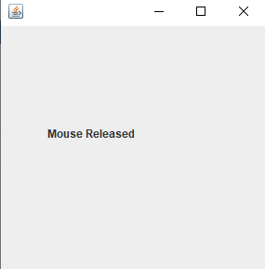

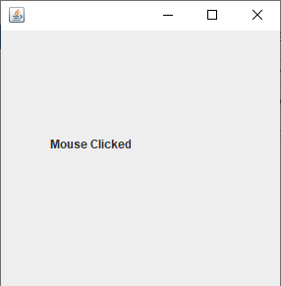 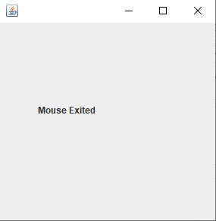

**WEEK – 13**

**13.a)** Create an interface containing 3 radio buttons named line, rectangle and oval. Based on the radio button selected, allow user to draw lines, rectangles or ovals as per the locations selected by the user.

**PROGRAM:**

import javax.swing.*;

import java.awt.*;

import java.awt.event.*;

public class w13_a extends JFrame implements ActionListener{

JRadioButton lineRad, rectRad, ovalRad;

JTextField xAxisField, yAxisField;

JButton submit;

int offset = 0, xAxis = 200, yAxis = 200;

w13_a(){

ButtonGroup btnGrp = new ButtonGroup();

submit = new JButton("Draw Shape");

xAxisField = new JTextField("200", 10);

yAxisField = new JTextField("200", 10);

lineRad = new JRadioButton("Line");

rectRad = new JRadioButton("Rectangle");

ovalRad = new JRadioButton("Oval");

lineRad.setSelected(true);

btnGrp.add(lineRad);

btnGrp.add(rectRad);

btnGrp.add(ovalRad);

submit.addActionListener(this);

JPanel panel = new JPanel(new FlowLayout(1));

JPanel panel1 = new JPanel(new FlowLayout(1));

panel.add(lineRad);

panel.add(rectRad);

panel.add(ovalRad);

panel1.add(xAxisField);

panel1.add(yAxisField);

add(panel);

add(panel1);

add(submit);

setSize(400, 500);

setLayout(new FlowLayout(1));

setVisible(true);

setDefaultCloseOperation(3);

}

public void actionPerformed(ActionEvent e){

xAxis = Integer.parseInt(xAxisField.getText());

yAxis = Integer.parseInt(yAxisField.getText());

if(lineRad.isSelected()){

offset = 0;

repaint();

}

if(rectRad.isSelected()){

offset = 1;

repaint();

}

if(ovalRad.isSelected()){

offset = 2;

repaint();

}

}

public void paint(Graphics g){

if(offset == 0){

super.paint(g);

g.drawLine(xAxis, yAxis, 100, 200);

}

if(offset == 1){

super.paint(g);

g.drawRect(xAxis, yAxis, 50, 50);

}

if(offset == 2){

super.paint(g);

g.drawOval(xAxis, yAxis, 60, 60);

}

}

public static void main(String[] args) {

new w13_a

();

}

}

**OUTPUT:**

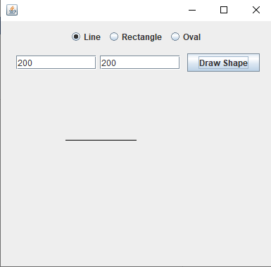

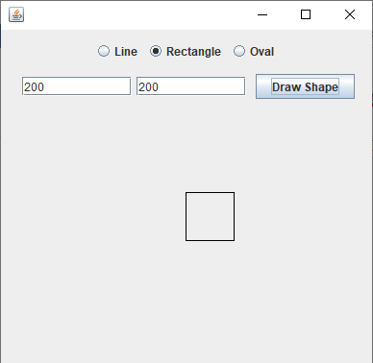

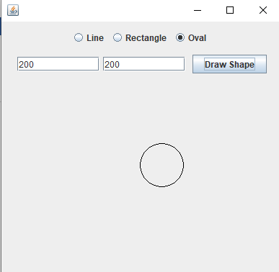

**13.b)** Write a program to create a Table inside a JFrame.

**PROGRAM:**

import javax.swing.*;

public class w13_b extends JFrame{

w13_b(){

JTable table;

String students[][] = {

{"Yuyeon", "121", "CSE"},

{"Elios", "122", "CSE"},

{"Richt", "123", "MBA"},

{"Peony", "124", "Hotel Management"},

};

String column[] = {"Name", "Roll Number", "Branch"};

table = new JTable(students, column);

JScrollPane scrollPane = new JScrollPane(table);

table.setBounds(10, 20, 360, 360);

add(scrollPane);

setSize(400, 400);

setVisible(true);

setDefaultCloseOperation(3);

}

public static void main(String[] args) {

new w13_b();

}

}

**OUTPUT:**

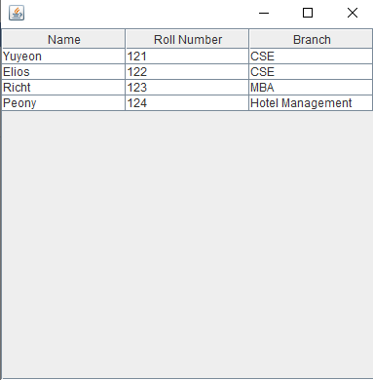

**13.c)** Create an interface that illustrates JFileChooser class and read CSV file containing employee data of various departments and display the records department wise on the interface.

**PROGRAM:**

import javax.swing.*;

import java.awt.*;

import java.awt.event.*;

import java.io.*;

import java.util.*;

public class w13_c extends JFrame implements ActionListener, ItemListener{

//components

JMenuBar menuBar;

JMenuItem openFile;

JComboBox<String> deptBox;

JFileChooser fileChooser;

JLabel label;

//arrays and sets for storing the data in File

String[][] fileInfo = new String[100][3];

HashSet<String> deptSet = new HashSet<String>();

int id = 0;

w13_c (){

menuBar = new JMenuBar();

openFile = new JMenuItem("Open File");

deptBox = new JComboBox<String>();

label = new JLabel();

//adding components to menubar and making combobox invisible

//until the user selects the file

menuBar.add(openFile);

menuBar.add(deptBox);

deptBox.addItem("none");

deptBox.setVisible(false);

//Registering Events

openFile.addActionListener(this);

deptBox.addItemListener(this);

add(menuBar);

add(label);

setSize(250, 500);

setLayout(new FlowLayout(1, 10, 10));

setVisible(true);

setDefaultCloseOperation(3);

}

public void actionPerformed(ActionEvent e){

fileChooser = new JFileChooser(System.getProperty("user.dir"));

int i = fileChooser.showOpenDialog(this);

//opening the selected file and reading the content in it.

if(i == JFileChooser.APPROVE_OPTION){

deptBox.setVisible(true);

try{

File file = fileChooser.getSelectedFile();

Scanner scanFile = new Scanner(file);

while(scanFile.hasNext()){

String[] employee = scanFile.next().split(",");

//adding an item to combobox if it is not department set

//and then adding that department to deptSet

if(!deptSet.contains(employee[1])){

deptBox.addItem(employee[1]);

}

deptSet.add(employee[1]);

fileInfo[id++] = employee;

}

scanFile.close();

}catch(Exception exp){

System.out.println(exp);

}

}

}

public void itemStateChanged(ItemEvent e){

String[][] filteredInfo = new String[50][3];

StringBuilder filteredLbl = new StringBuilder();

int fid = 0;

for(int m = 0; m < id; m++){

if(e.getSource().toString().contains(fileInfo[m][1])){

filteredInfo[fid++] = fileInfo[m];

}

}

StringBuilder lbl = new StringBuilder();

for(int m = 0; m < fid; m++){

lbl.append(filteredInfo[m][0] + " | " + filteredInfo[m][1] + " | " + filteredInfo[m][2] + "\n");

}

filteredLbl.append("<html>" + lbl.toString().replace("\n", "<br/>") + "</html>");

label.setText(filteredLbl.toString());

}

public static void main(String[] args) {

new w13_c ();

}

}

**OUTPUT:**

